RESTAURANT DATA ANALYSIS USING PYSPARK

Use Cases

Use Case 1: Global Cuisine Popularity
Description:
This use case identifies the most popular cuisines by splitting and counting each cuisine individually.
Code:
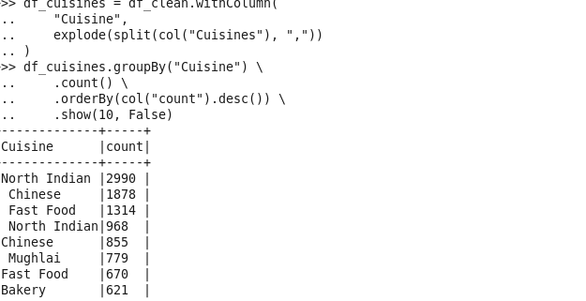

Use Case 2: Cost Comparison
Description:
This use case compares the average cost of restaurants across different countries.
Code:
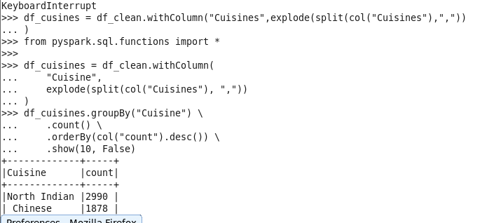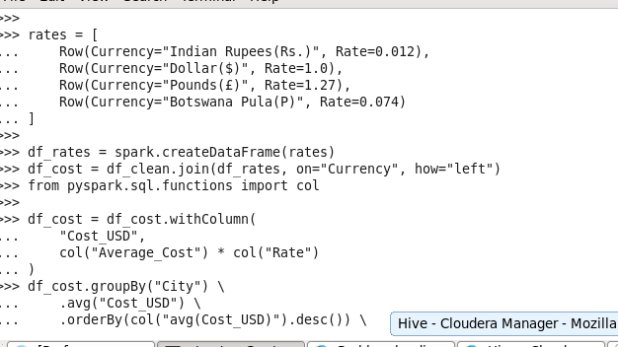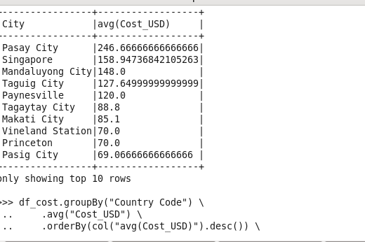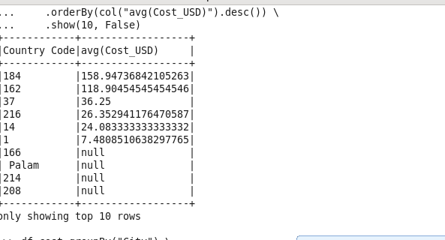

Use Case 3: Impact of Services on Ratings
Description:
This use case analyzes how services like online delivery and table booking affect customer ratings.
Code:
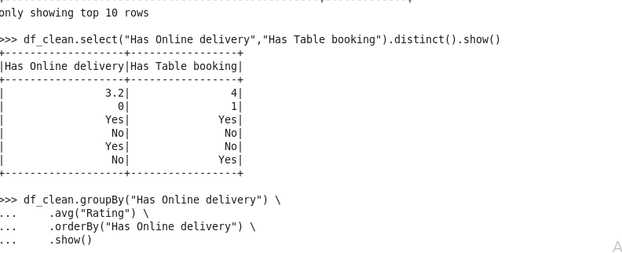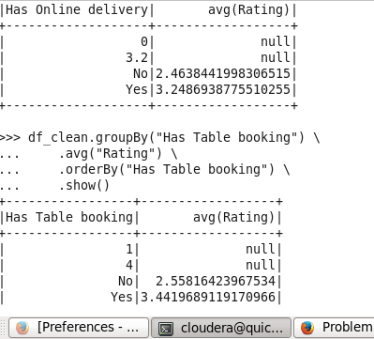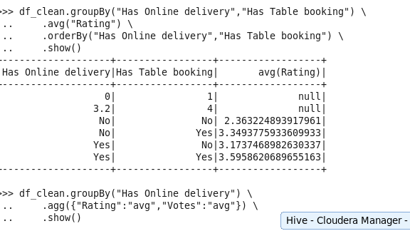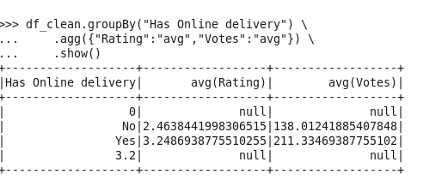

Use Case 4: Hidden Gems
Description:
This use case identifies highly rated restaurants that also have a significant number of votes.
Code:
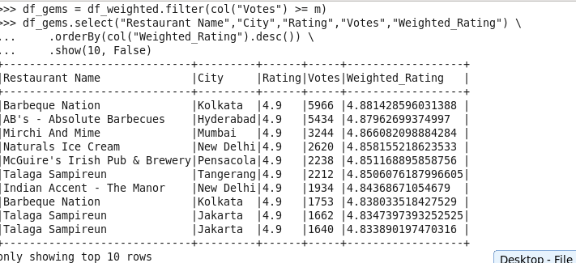

Use Case 5: Restaurant Clustering
Description:
Restaurants are grouped into categories such as budget, mid-range, and luxury based on cost and ratings.
Implementation:
A rule-based approach was used due to system limitations.
Output:
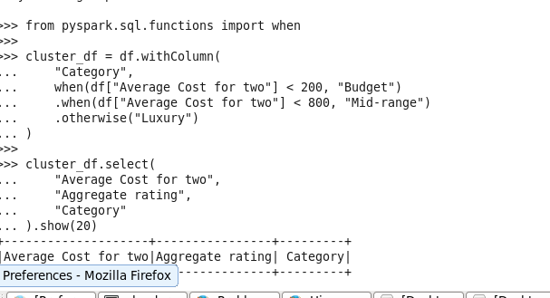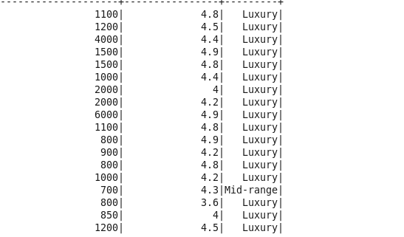

Use Case 6: Food Hub Detection
Description:
This use case identifies cities or areas with a high number of restaurants.
Code:
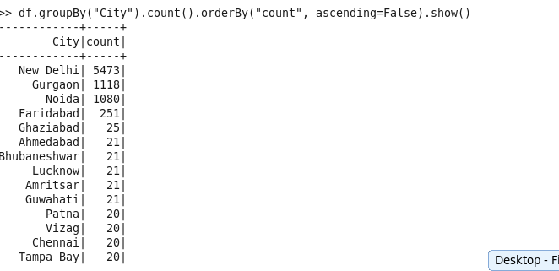

Use Case 7: Data Cleaning and Standardization
Description:
This use case cleans the dataset by removing null values, eliminating duplicates, and standardizing text fields.
Code:
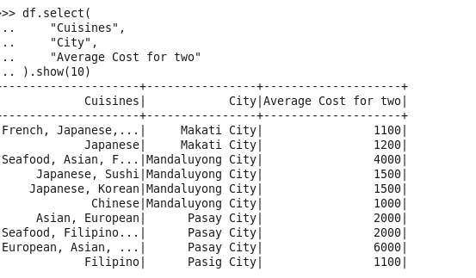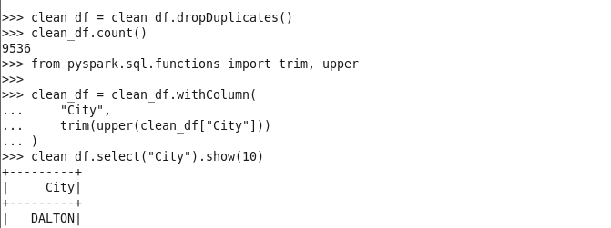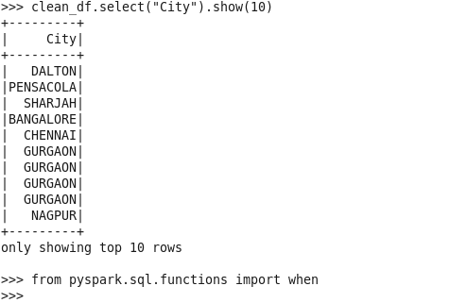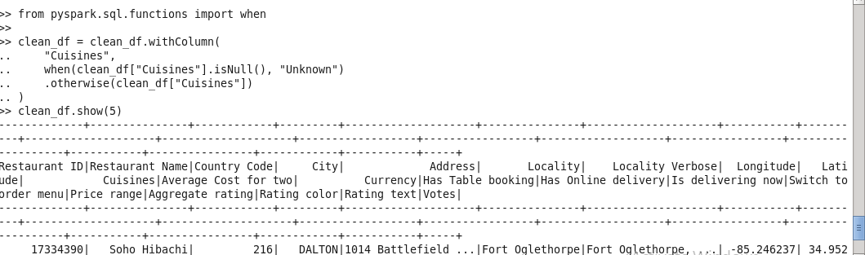

Use Case 8: Price Range Distribution
Description:
This use case analyzes how restaurants are distributed across different price ranges in various localities.
Code:
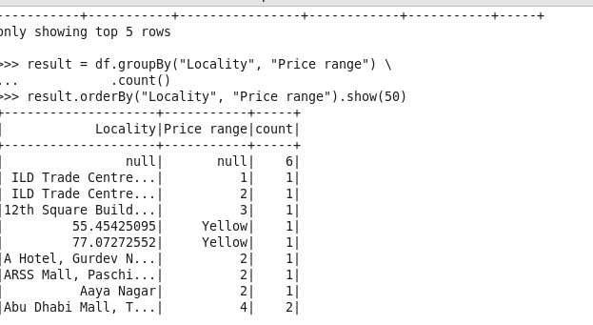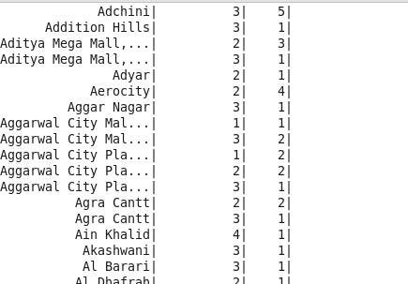

Use Case 9: Price Prediction
Description:
A rule-based method is used to predict the price category of:
restaurants based on their ratings.
Code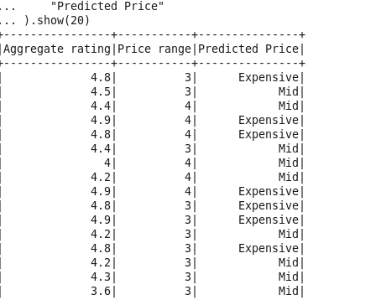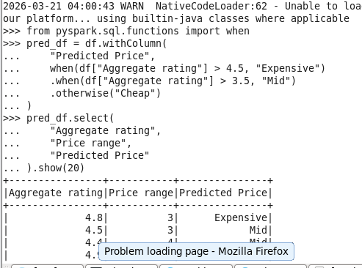:

Use Case 10: Recommendation Engine
Description:
This use case recommends restaurants based on similar cuisines and locations.
Code:
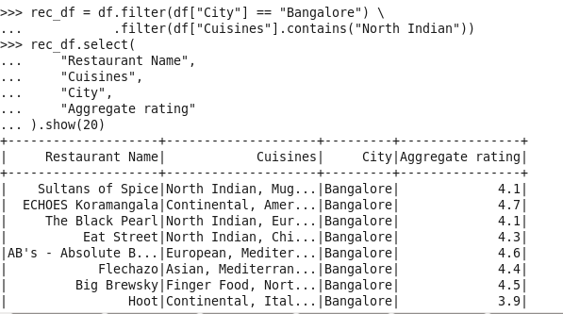

Use Case 11: Broadcast Join
Description:
This use case demonstrates how broadcast join can be used to improve join performance between large and small datasets.
Code:
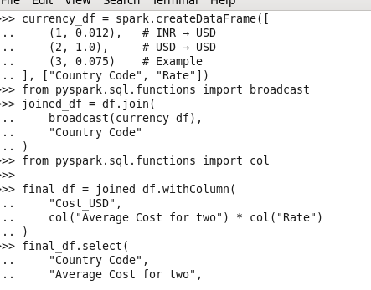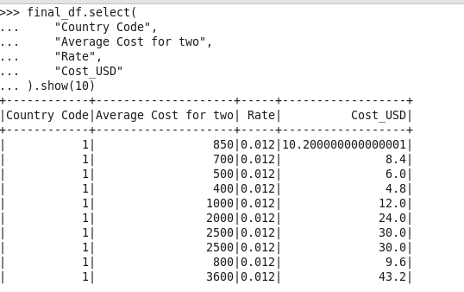

Use Case 12: Caching and Storage Optimization
Description:
This use case improves performance by caching data and storing it in Parquet format.
Code:
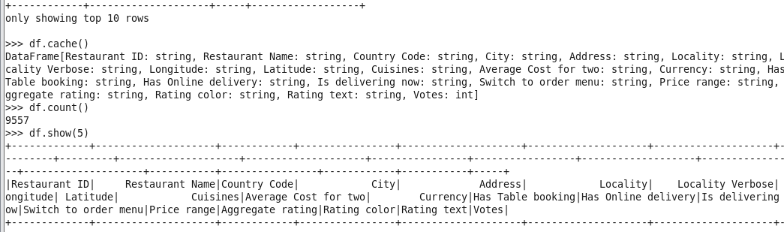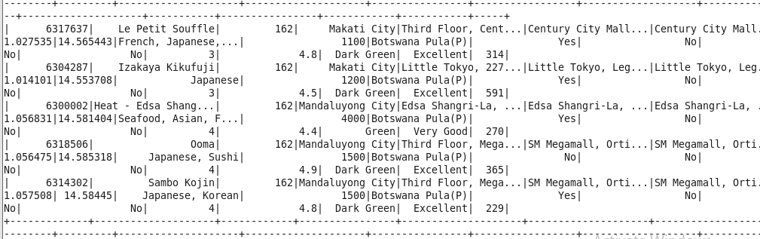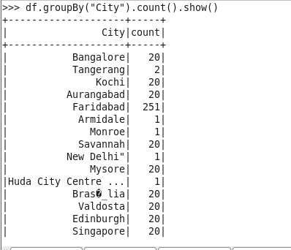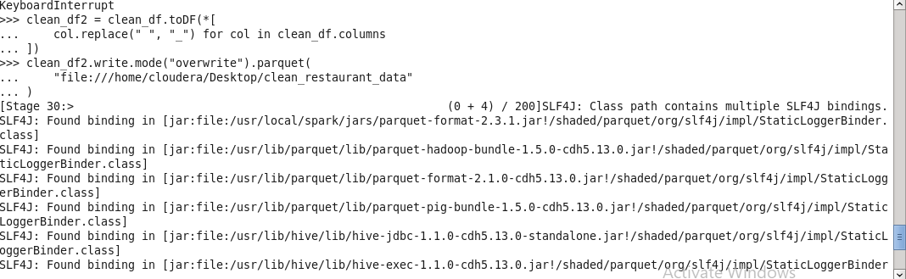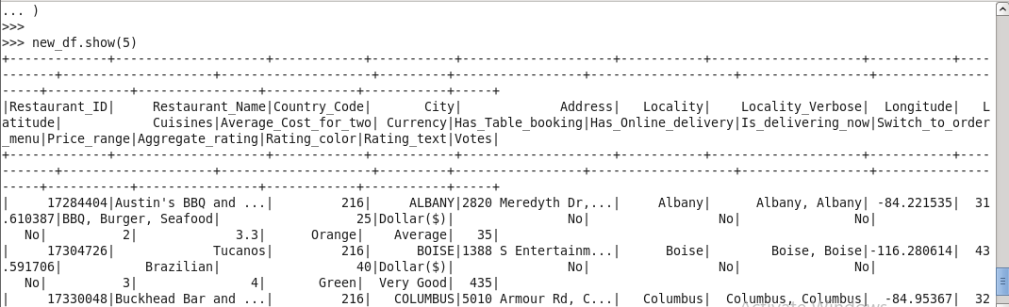

Use Case 13: Service Impact Comparative Analysis
Description:
This use case analyzes how services such as online delivery and table booking influence customer ratings. Instead of visualization tools, aggregated statistics are used to understand rating distribution.
Code:
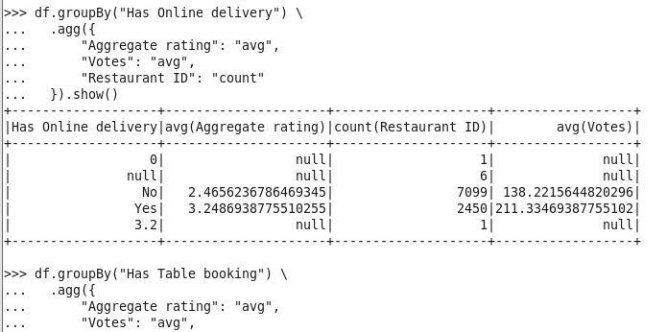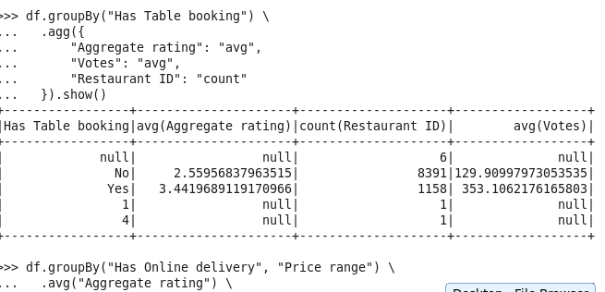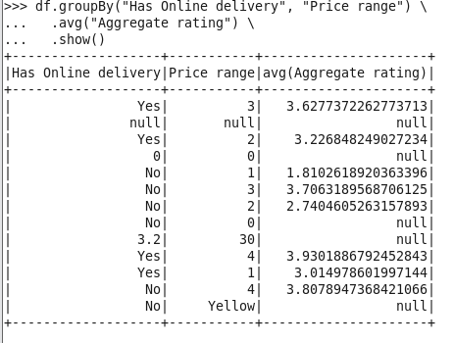

6. Optimization Techniques
- Broadcast join to reduce data shuffling
- Caching to improve processing speed
- Parquet format for efficient storage

Conclusion
This project demonstrates how PySpark can be used for large-scale data processing and analysis. Various insights were derived from the dataset, and optimization techniques were applied to improve performance.

